Project report

2018/12/20

Student name: AKRAM ALKDDEH  
Student number : 2016710213059

Student name: BASHAR KHATIB

Student number : 2015710213101

Our aim from this program is to make a connection between one or two or three etc..

numbers of clients together through the server program and they can **chat** with each other and send **files** (**dosya**).

First, we will talk about the a program step by step…   
**FIRST** step is , we should open the server program then the server will automatically will take the ip of the computer which is running the program on.

**SECOND** step we open the client program and write the ip of the server to allow the communication operation among the clients.

**THIRD** the client program will ask you to enter your client name and then a message will pop up “to enter a message press 1 to send file press 2” and at the same time another message will pop up in server program when the connection between the server and the clients are done.

**FORTH** now we have two choices to choose the first one is sending a message and the other choice is sending a file.

if you want to send a message through the server from one client to others press “1” after that you can type your message immediately and send it , the other one is sending a file and it is done by pressing “2” after pressing 2 you should enter the file location after that it asks you to enter file name ,but if it is in the same folder just enter the file name without location.

To test this program we made three folders named client1,client2,client3 and each folder contains the client program and download folder (this folder will receive files and store them) and we need to make sure that we have two important library which are they necessary for running the program the first library is (msvcr100d.dll) and its important for tcp/ip protocol and the other one is (bi thread) and it is important for bi threading.

Now we will illustrate this steps by some screenshots and display the steps respectively:

we can run both the server and client from debug folders.

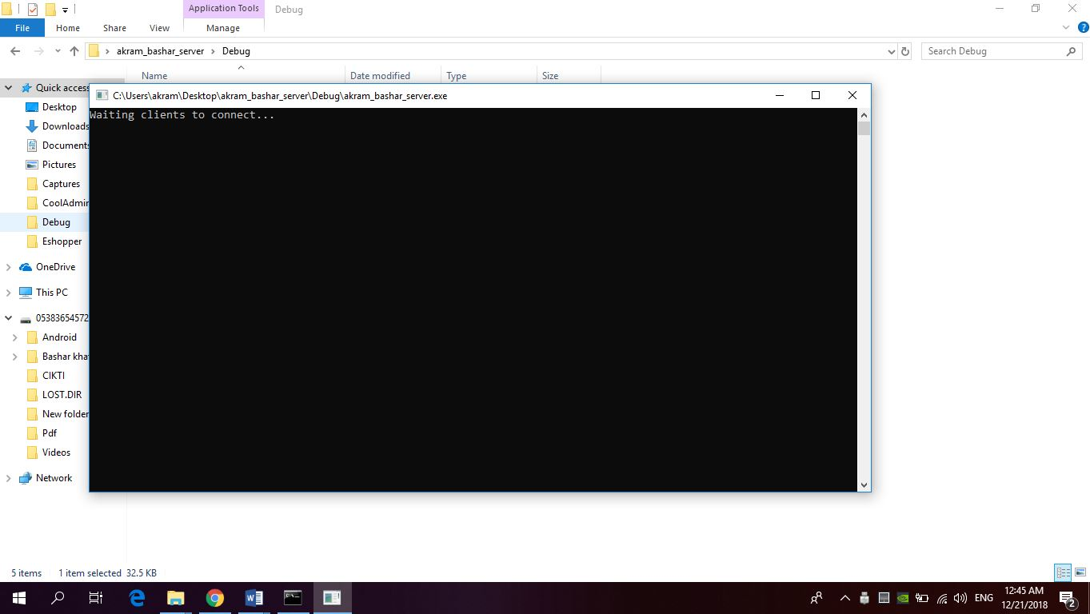  
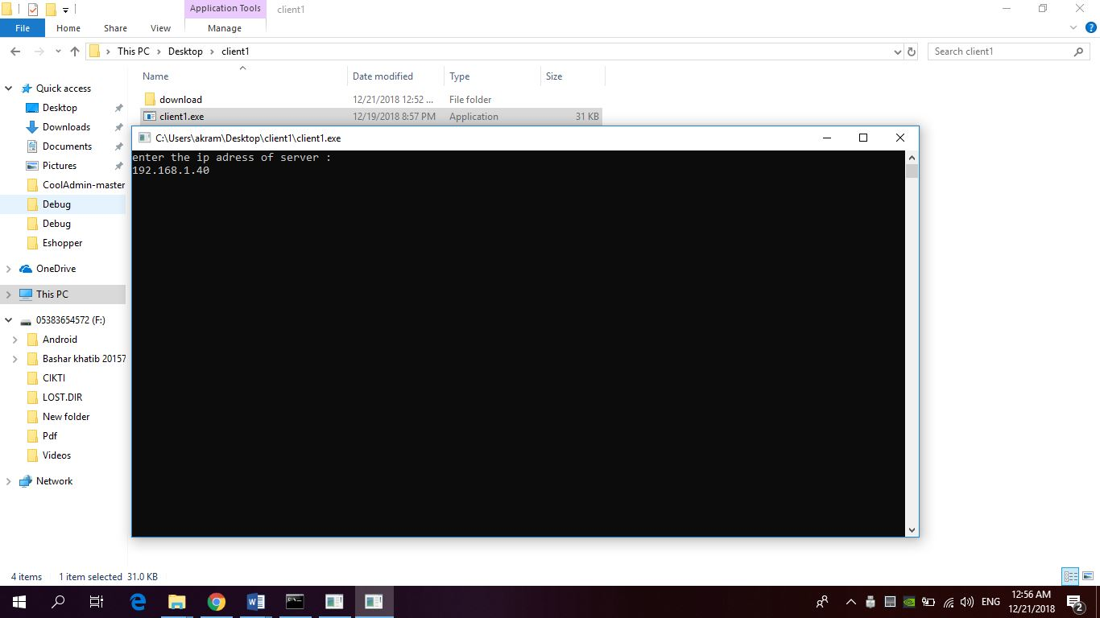

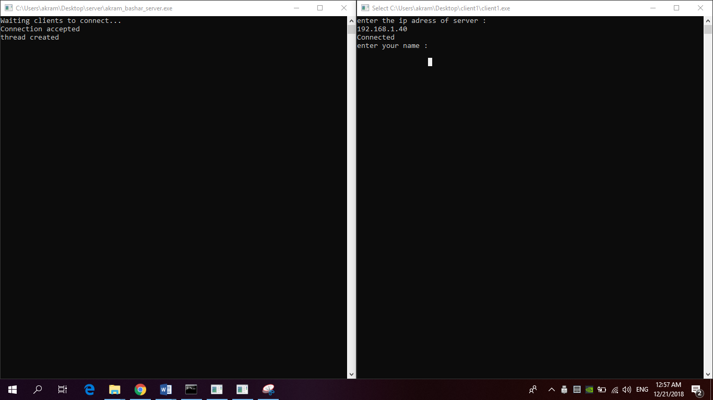

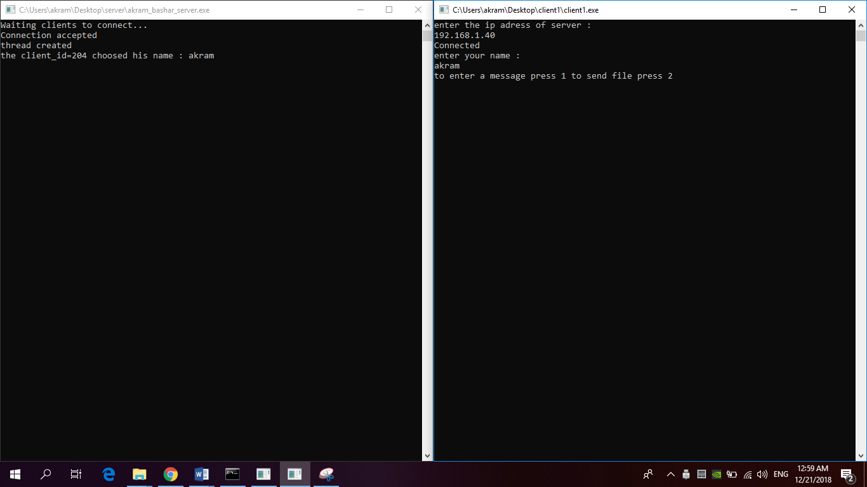

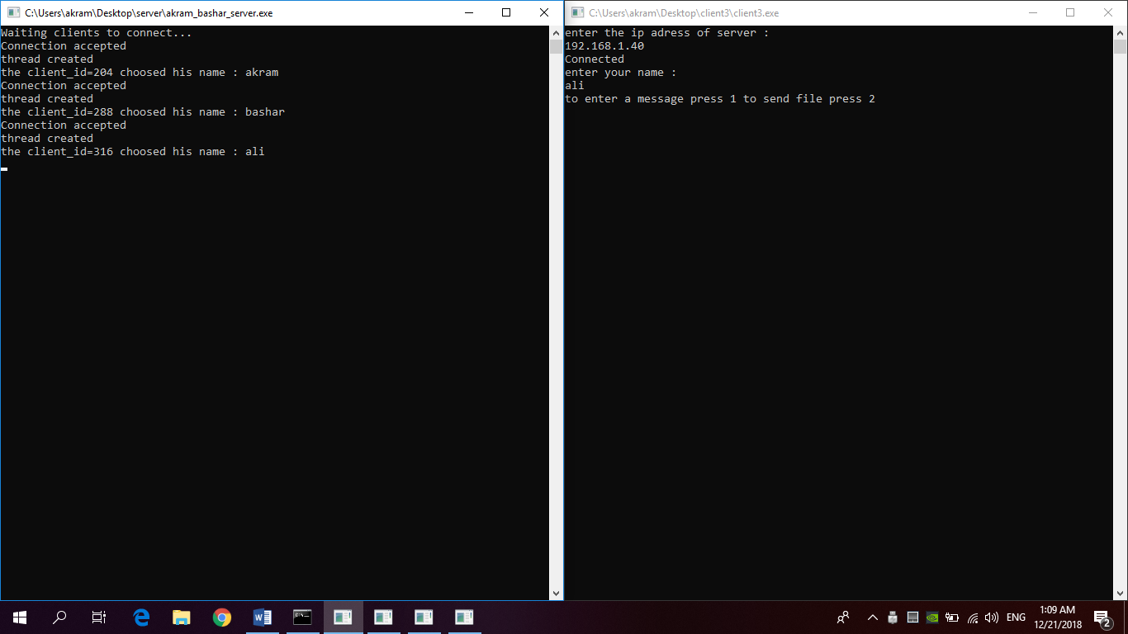

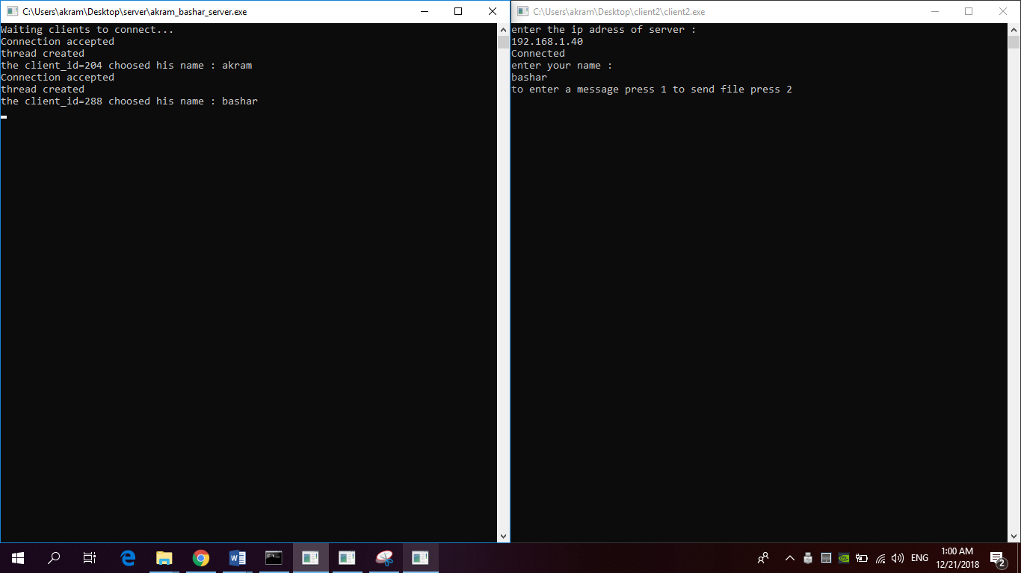

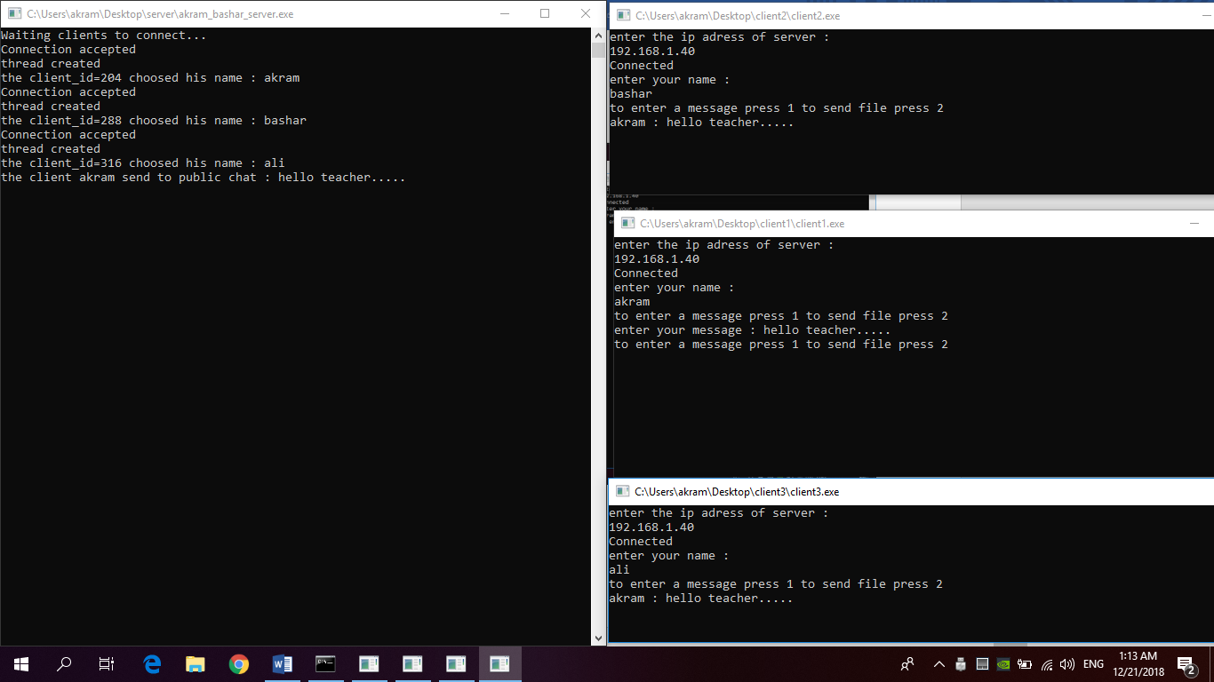

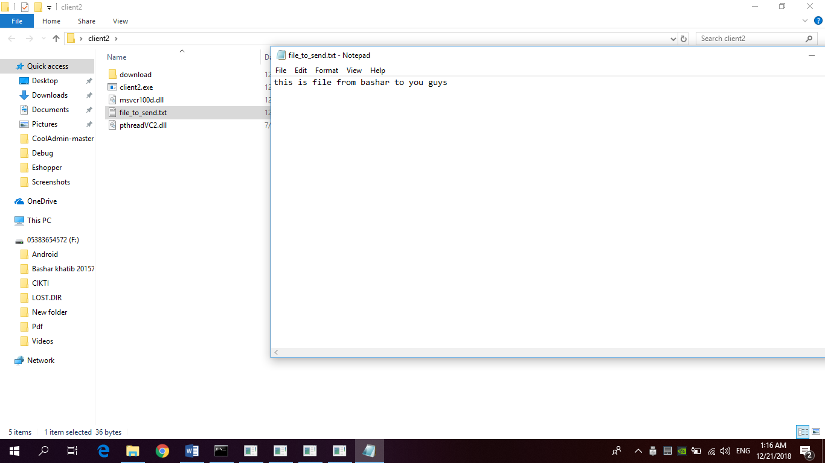

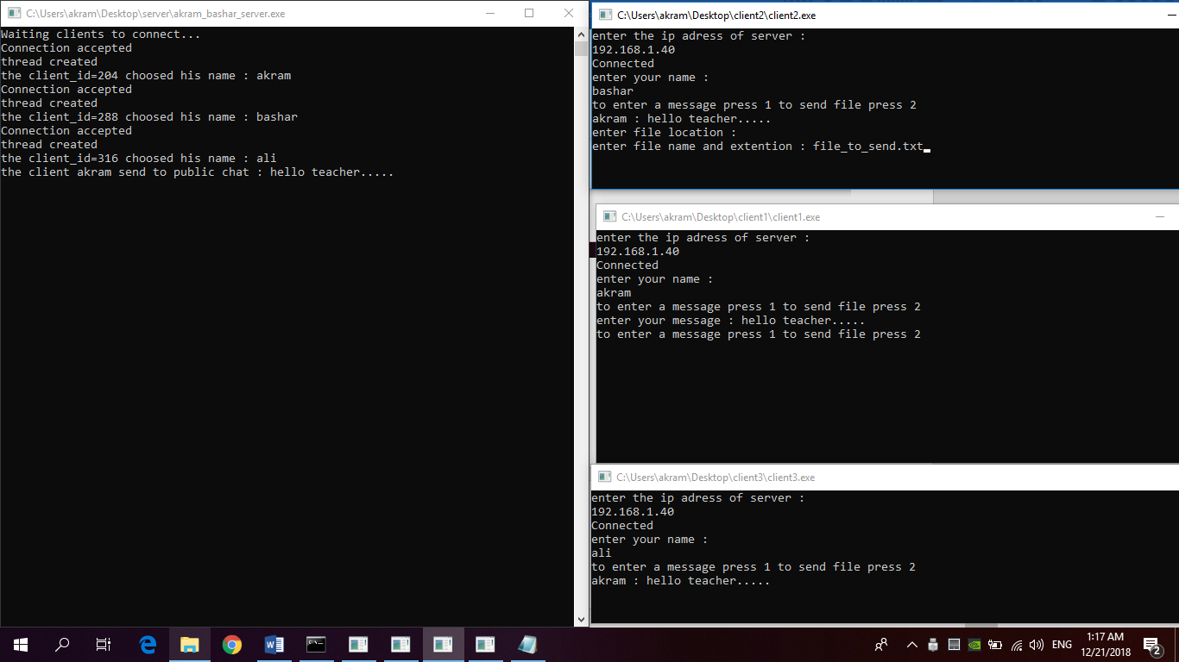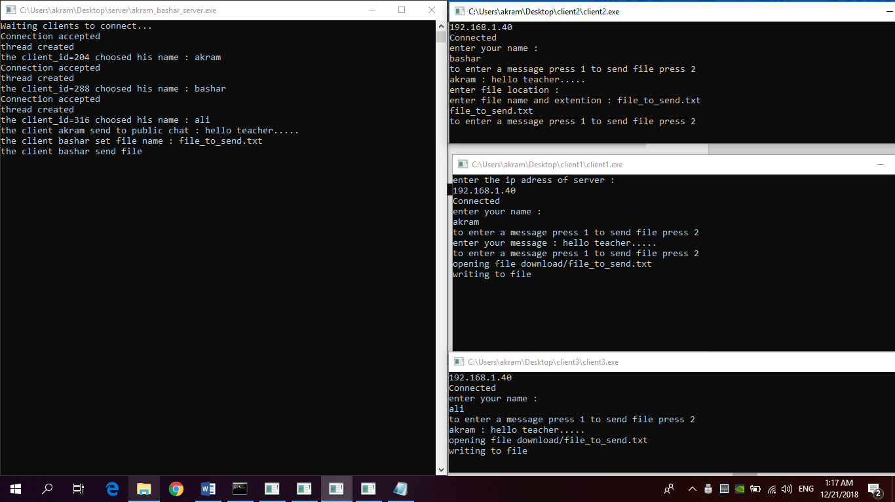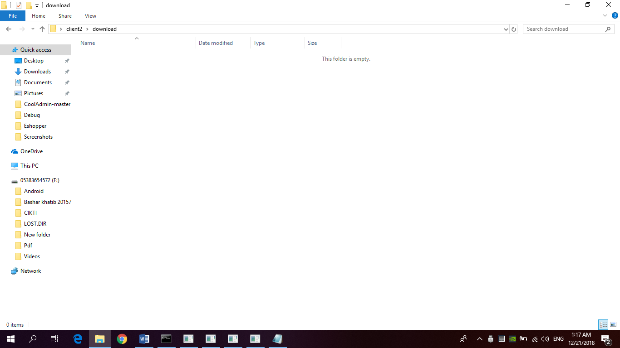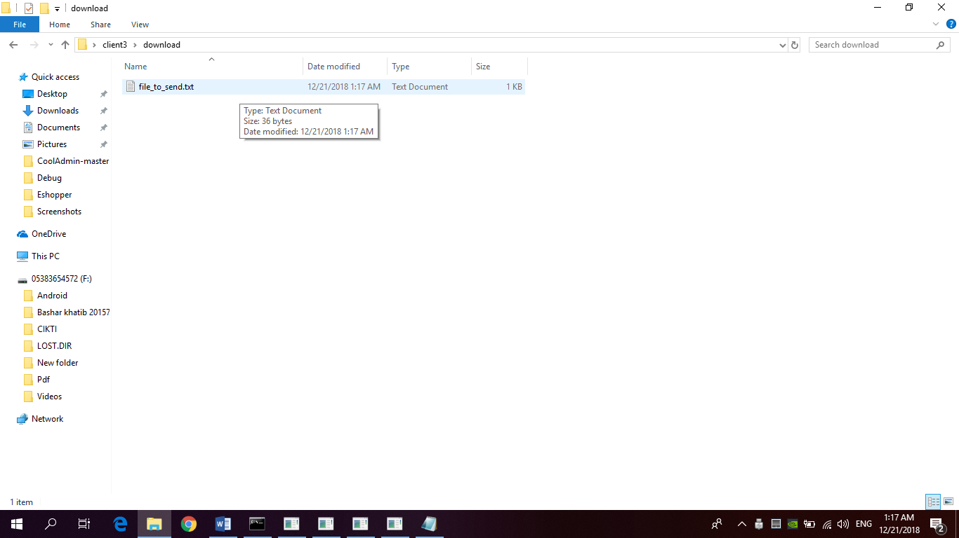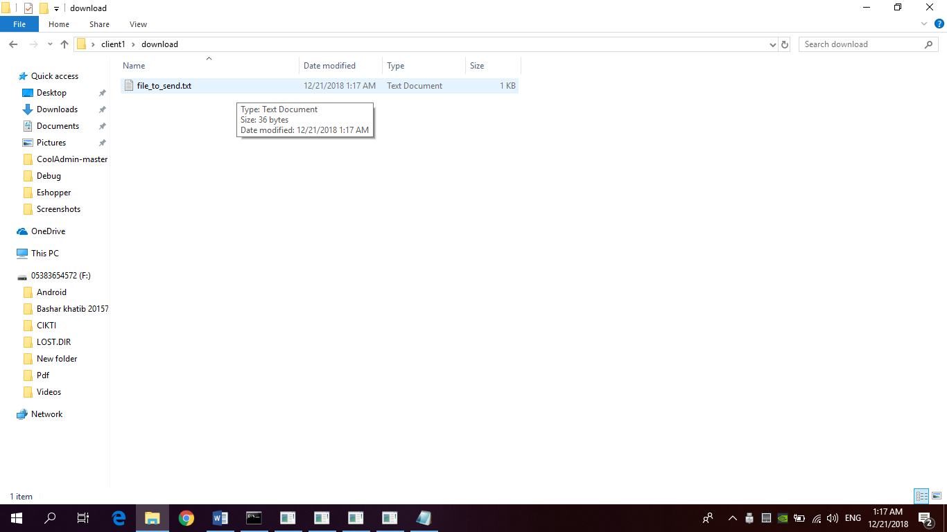

Source code for server : [here](server_tcp.txt)

Source code for client : [here](client_tcp.txt)

We Made This Project by getting help from multiple sources ..

1-youtube: https://www.youtube.com/watch?v=4GdTcqE0iqg

We followed this tutorial to link pthread library to our project..

2-our friend from 4’ class “HASAN KHATIB” helped us to solve some problems we faced ..